**Virtual Environment**

Steps to create Virtual Environment

**Step 1**: Installing virtualenv

On Windows:

py -m pip install --user virtualenv

On macOS and Linux:

python3 -m pip install --user virtualenv

**Step 2**: Creating a Virtual Environment

On Windows:

py -m venv Beam_Streaming

On macOS and Linux:

python3 -m venv Beam_Streaming

The second argument is the location to create the virtual environment. Generally, you can just create this in your project and call it env.

**Step 3**: Activating a Virtual Environment

On Windows:

.\Beam_Streaming\Scripts\activate

On macOS and Linux:

source env/Beam_Streaming/activate

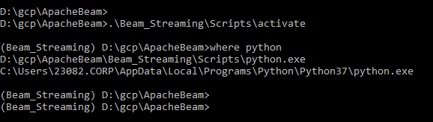

**Step 4**: Installing the packages

pip install requests

**Step 5:** Leaving the Virtual Environment

deactivate

Reference : <https://packaging.python.org/guides/installing-using-pip-and-virtual-environments/>